MP3 file update tutorial

1. Turn off the forklift power supply。
2. Prepare a computer and a micro USB cable,
3. Insert the micro USB cable into the MP3 USB port and connect the other end to the computer usb, as shown in the picture:

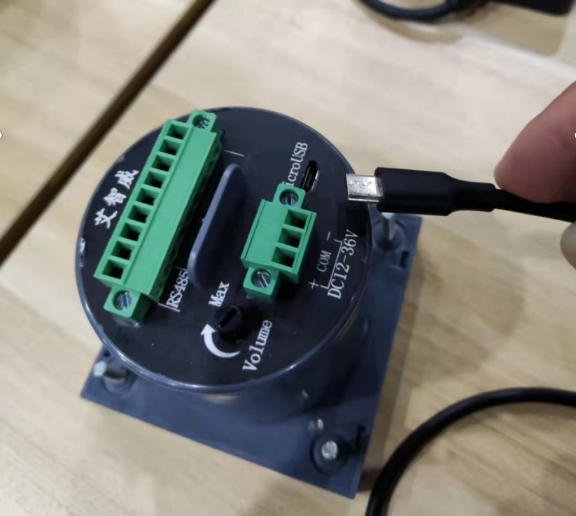

1. Not installed

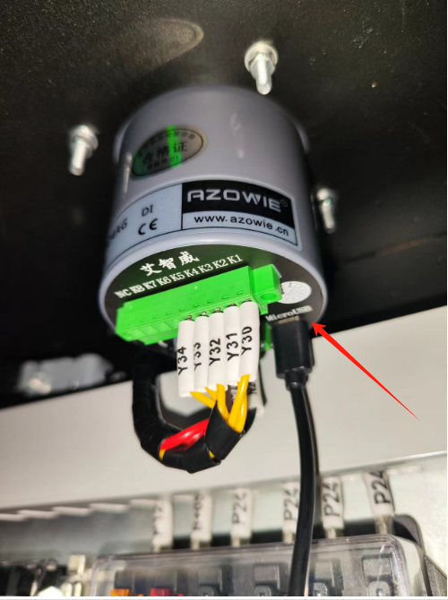

1. When installed
2. After connecting the USB cable, the computer will display a USB drive icon, open the USB drive file, you will see many folders, the folders named AW+xxx, xxx is the channel number.

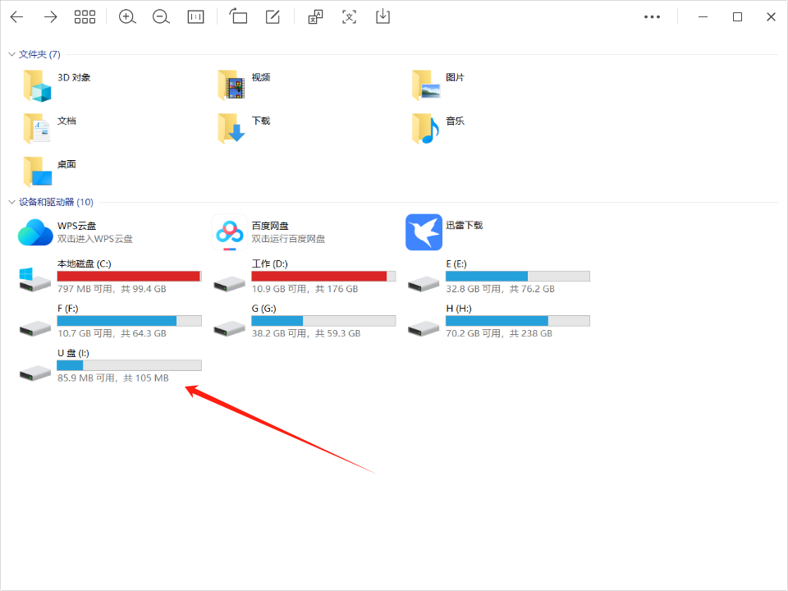

1. USB drive icon

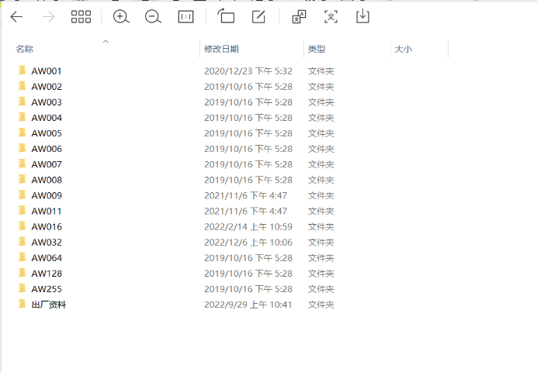

1. Music folders
2. Select the folder that needs to be replaced, for example, if we select the frist channel, open the AW001 folder, delete the original music file and replace it with a new one, note that only MP3 format music is supported.

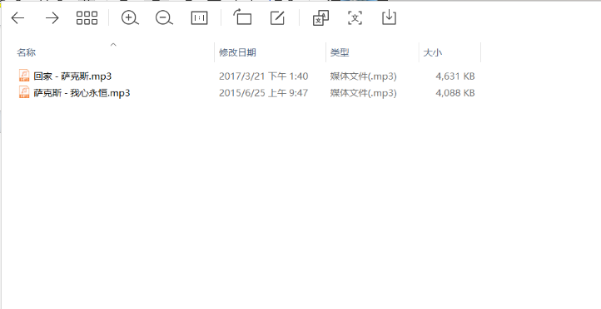

1. New music file
2. If all replacements are completed, closed the USB dirve, unplug the USB cable and open forklift power, then you can send commands to make MP3 Player work.